Real-life portraits of the modern family

Demographics and family traditions in Canada are changing. Here’s our album of five real families, sharing their stories and celebrating the wonderful ways we’re parenting in 2014.

Mar 13, 2014 Karen Robock 0

TORONTO
STAT: The number of same-sex married couples has nearly tripled since 2006.*

Photo: Vanessa Heins
Family members: Mathew Howard, 33, grad student; husband, Mitsuru Delisle, 35, architect; sons Tyler, 5, and Riley, 2.
Eight years ago, Mathew Howard emigrated from Australia after falling in love with a nice Canadian guy. They settled down in Toronto and, a few years later, adopted two boys from foster care. Here’s how these busy dads are balancing work, school and fatherhood.
What makes your family unique? Being a same-sex couple with adopted kids makes us unique in some ways, but there are actually a lot of same-sex parents in our neighbourhood. I’m Australian and Mitsuru grew up in Victoria, BC, and he’s half Japanese, one-quarter First Nations and one-quarter French-Canadian, so that gives us a bit of a different perspective, too. But we feel lucky to live in Toronto—there’s so much diversity.
How would you describe your parenting philosophy? I would call it seat-of-the-pants parenting. We adopted the boys two years ago, but most of the time we still feel like we have no idea what we’re doing. One thing we really focus on is giving them as much agency as we can. Adopted kids can feel a lack of control over their lives, so allowing them to make decisions, even about small stuff like what to get at the grocery store, is really important.
What’s the most unexpected thing you discovered after becoming a dad? Obviously both of us put a lot of ourselves into being parents, especially during the first year. But you realize eventually that if you don’t find time to nurture your own interests and passions, then you really can’t be the best parent for your kids. Finding the right balance is hard.
How do you handle child care? Tyler goes to Montessori school every day and Riley has daycare three days a week. Mits takes Tyler on his way to the office, and I drop off Riley. I pick them both up in the afternoon around 3:30. On the days they’re both out of the house, I have a chance to study.
What’s been the biggest challenge for your family? The adoption process took about two years but felt like it was overnight. We woke up one morning and suddenly had two kids—including a baby—and it was like, Oh my God. We knew we wanted to adopt siblings, so we could keep a family together, but it was a big adjustment. The other hard part about adopting is that there are so many kids you would love to adopt, but you realize that you don’t have the resources or the skills needed to give them the best life. That’s really humbling.
What’s in your daily parenting tool kit? Extra clothes—we’re potty training Riley. I’ve learned the hard way that if I don’t have spare clothes and snacks with me at all times, I’m in trouble. I wish that had been in the manual when we adopted the kids. It should say, “Your kids will have tantrums if they don’t eat every hour.” That would’ve been helpful.
Do you have a go-to meal that everyone will eat? Lentil stew with rice has become a staple. Food was a big thing for Tyler when the boys came to live with us. What he was eating at the foster home was very different from what we eat, so we had to slowly introduce new foods and figure out what he liked. He kept asking for “brown soup”—it’s all he wanted to eat. I made every kind of brown soup known to man, but it was never right. A year later we figured out that he meant gravy. Gravy! They’re both good eaters now, though.
What’s your favourite family activity? We don’t have a car, so one of our favourite things to do is take the cargo bike to Toronto Island or just ride around and explore the city. We’ve also gotten into this habit lately of going to a pub on Sundays for lunch. Mits and I can have a beer while the kids tell us all their little stories—they’re turning into great conversationalists.
—-
SASKATOON
STAT: 5 percent of kids live with a grandparent, and 18 percent of Canadians speak two languages at home.
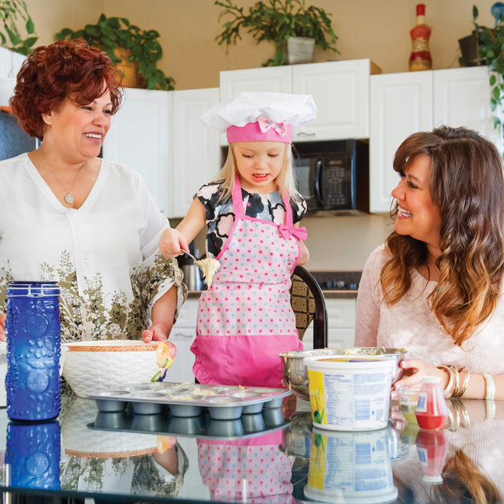
Photo: Chris Hendrickson Photography
Family members: Julie Macfarlane, 39, pharmaceutical rep; daughter, Morgan, almost 3; her mother, Sabah Salter, 63, retired.
Julie MacFarlane and her daughter moved in with her mother after a divorce. Here’s how the three generations are supporting each other.
Do you have a parenting philosophy? Consistency, basic consequences (like time outs for bad behaviour) and making sure that Morgan knows she’s loved no matter what. My mom looks after Morgan while I work, and she’s really respectful of what I want, but I also look to her for parenting advice. She ran a daycare for 20 years, on top of being a mom herself, so she knows a lot about caring for kids, and I respect her judgment.
Read more: How to discipline with different parenting styles >
What makes your family unique? I was born in Cairo, and we moved to Canada from Egypt in 1979. My mom felt it was important for us to know our Egyptian culture, and I want that for my daughter, too. My mom speaks Arabic to Morgan (Morgan calls her Situ, which is “Grandma” in Arabic) and we expose her to as much of the culture as we can. Every weekend we have the extended family over for dinner and have authentic Mediterranean-style dishes and listen to Arabic music. One of my aunts just brought back the cutest little belly dancing outfit for Morgan, and she loved dancing for everybody.
Do you know a lot of families like yours? Most of the families in our neighbourhood are couples with young kids, or empty nesters, so three generations under one roof certainly isn’t the norm. But, culturally, it isn’t unusual. As more ethnic families move to Saskatoon, I think it will be more common to see grandparents living with their kids and grandkids.
What do you worry about the most? As a parent you’re always concerned about your child’s health and safety—that’s number one. I’m also concerned about my own health, so I can be there for her through all of the important milestones, from the first day of school to the first time her heart gets broken. I’m definitely taking care of myself in a way now that I wasn’t before becoming a mom.
Is there a go-to no-fail meal that everyone will eat? We don’t have a word for it in English, but Morgan loves an Egyptian soup that you pour over rice. She can’t get enough of it. I was surprised because it’s made of green leafy vegetables and people either love it or hate it.
Which so-called “parenting rules” do you break all the time? At first I was a real drill sergeant about bedtime, because I wanted to get her on a routine, but now I let her skip a nap if we’re going somewhere, or stay up late to watch a movie with us. As long as kids know what the rules are, I think it’s OK to break them occasionally, especially if it’s for something special.
What’s your secret to a happy you? I started a gratitude journal after the end of my marriage. At first it felt hokey, and I didn’t know if it would do me any good, but it really has. Every night before bed I write down five things I’m thankful for. Number one is always my healthy and happy daughter—that’s easy. What’s amazing is that even at the end of the most challenging day, I can always come up with four more things. It’s helped me build a better sense of gratefulness.

REVELSTOKE, BC
STAT: One in ten children in Canada now live in blended families.
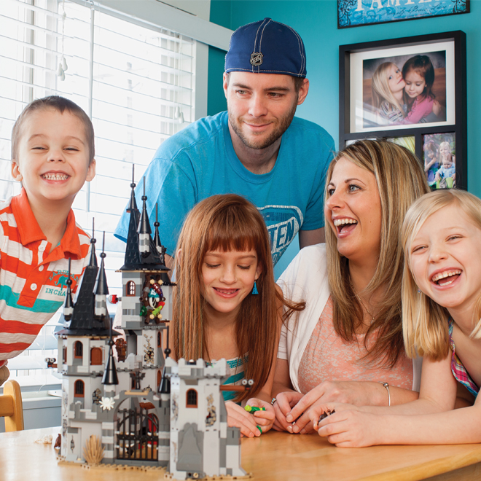
Photo: Kerri Knapp
Family members: Erin Russell, 33, bank employee; husband, Chris Russell, 37, saw filer at a lumber mill; daughters Arwynn, 10, and Taylor, 8; son, James, 4.
Erin Russell juggles the needs of three kids, keeps track of three household schedules, negotiates the needs of all four parents, and somehow makes it all work for her blended family of five.
Would you describe your family as unique? We’re a blended family, but you can’t really tell when you first meet us. It’s his, mine and ours, but there really is no separation. When I met Chris, my daughter Taylor was one and his daughter Arwynn was three. The girls just bonded right away and they’ve always been close. And then we had James four years ago. It’s like the kids have always been together.
What are your family’s biggest challenges and biggest victories? Every family decision that my husband and I make affects three households, not just ours. Coordinating everyone and being sensitive to everybody’s needs is a challenge. If we want to make plans for the weekend, for example, we have to first figure out if the kids are even going to be at our house on those days. (Taylor stays with her dad every other weekend and Arwynn is with her mom for two weeks at a time.) It’s a balancing act that we’ve had to figure out over the years. It’s easy to think it would be simpler for them to just be with one parent full-time, but I don’t think that’s what’s really best for them. Our kids are for​tunate because they have two support systems. They have so many more people to love them, be there for them and be role models. I can’t even tell you how many grandparents, aunts and uncles they have. Our biggest victory is that we make it all work.
How do you balance work, all these schedules and child care? I was a stay-at-home mom, but when James started preschool this year I went back to work full-time. The bank allows me to be a bit flexible with my hours, and I have Mondays off. James’s preschool is in the girls’ elementary school, so they all go together in the mornings, then I pick up James during my lunch hour to take him to daycare. During the weeks that Arwynn is with her mom, Chris works an evening shift, from 3:30 p.m. until midnight, and Chris’s mom takes Taylor and James after school until I get home from work. We’re also a one-car family, so we have to be creative.
What’s bedtime like at your house? The kids get ready for bed at the same time, even though there’s such a big age gap. They usually end up in the bathroom together to brush their teeth. While my husband and I put James to bed, the girls sit in their beds and read or do something quietly in their rooms. Once James is asleep my husband usually reads with Arwynn and I read with Taylor for a few minutes. Then we switch and go into the other girl’s room to say goodnight. The whole process starts at 8 p.m. and it’s usually lights out around 9 p.m.
Does your family have a go-to, no-fail meal that everyone will eat? The kids’ favourite is tacos. It’s a good one because there are lots of veggies; we usually include spinach for the toppings. They like it because they can make their own. There are usually no complaints—unless we have too many taco nights, and then it’s my husband who’s unhappy.
Describe your daily parenting tool kit—the three most important things you keep with you at all times. I always have my phone with me because it has everything in it, and keeping track of our schedules and play dates is very important. During the winter I have tissues and lip balm with me, too, because we walk a lot and there are always runny noses or dry lips. In the summer it’s a water bottle and a camera.
What’s the best parenting advice you ever got? To do what works for you. You have to figure out what makes sense for your family. Everyone has something that they’re going to tell you is a must, but at times you just have to ignore all that advice and do what works for you and your kids.
When was the last time you looked around and thought, “This is a really good moment?” I had a great one recently at the weekly assembly at the girls’ school. They did a slideshow at the end and there was a picture of Arwynn and Taylor at recess, arms around each other, smiling. It was so obvious that these kids love each other, and in that moment I felt so proud. I went home and told my husband, “We must be doing something really right.”
FORT GOOD HOPE, NWT
STAT: We’re having kids later in life. For the first time ever, most new moms are now older than 30, and 2 percent of first-time moms are older than 40.

Photo: Angela Gzowski
Family members: Karey Kraeker, 42, stay-at-home mom; husband, Reggie, 35, RCMP officer; daughter, Bree, 2.
It isn’t easy living in a small, fly-in Northern community, but Karey Kraeker, a 42-year-old stay-at-home mother, finds creative ways to fill her family’s days.
What’s a typical day like at your house? We live in a community of 500 people in a very isolated area—you can only get here by plane—so our days are probably pretty different from the norm. My daughter wakes up between 6 and 6:30 a.m. If my husband is working the day shift, he gets up with us and has breakfast before heading out. A lot of our day is spent inside because there’s no grass around the houses where Bree can play, and she’s too small to use the playground at the school. In good weather, we go for long walks and we use our imaginations. I find a lot of craft ideas on Pinterest, and we bake, sing and play.
Do you have a go-to meal that everyone will eat? Spaghetti with garlic toast. But planning meals here is tricky. There are only two stores, and they’re really expensive. A jug of milk is $10. We get a Northern Allowance (paid by the government) to help offset the cost, but everyone here orders most of their packaged food, and clothes and gifts, ahead of time from Yellowknife. We do yearly orders for our dry goods, and then it’s delivered on river barges in the summer. I’m always opening the cupboards and noticing something that we’re running out of, and adding it to my big list for the next order.
Have you received any great parenting advice so far? When my daughter was born, my mom said to me, “Your house is going to be a mess, you’ll have laundry and dishes piling up and dust bunnies in the corners, but forget about all of that.” She told me to nap whenever the baby napped, to make sure I was rested and make the most of when the baby was awake by not spending it on cleaning, either. I’m still following that advice; I don’t do any housework when Bree is up. Kids are only little for such a short time—I’m making the most of it.
What’s the secret to a happy relationship? I’d have to say communication. My husband’s my best friend, and we can talk about anything. We’ve never really had a big fight. Sure we have tiffs, but if there’s something bothering us, we can always talk it out.
How is your family different from most of the families in your community? I’m older than all of the moms I know. And most of the people here are Metis, so we’re in the minority. We’re also here temporarily—my husband is on a two-year posting. We’ll probably be moving to another town next summer, but it’ll still be somewhere in the North.
What do you worry about the most? Because we’re so isolated, Bree has only been able to socialize with other kids her age a few times. I worry it might negatively affect her development in the long run.
Describe one of your favourite things to do as a family. This is going to sound a bit strange, but sometimes we just drive to the dump. We see bears, foxes and ravens there. Bree loves to see the wildlife, but we don’t get out of the truck!
How did you spend your last vacation? We take two one-month vacations a year. First we fly to Norman Wells (NWT), then to Yellowknife, then to Edmonton. We stay overnight in Edmonton and pick up the truck that we store there, then drive to Regina, where my family lives. That’s kind of our home base. We also go to Manitoba to visit my husband’s family, or we go on a holiday. Last year we took Bree to Disney World, and the year before we went to Mexico.
What do you like most about where you live? It’s a quiet life. There’s not a lot of rushing around. It’s a really beautiful place, right on the Mackenzie River, and in the summertime we have 24 hours of daylight for about two months—that’s really special.

LOWER SACKVILLE, NS
STAT: 16 percent of families with kids are single-parent families. (Among the Canadian provinces, Nova Scotia has the highest concentration of single parents.)
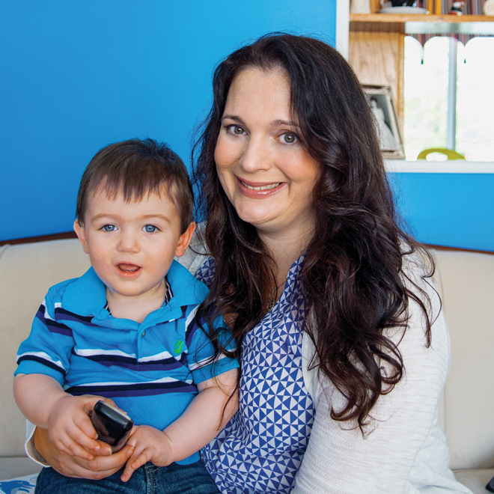
Photo: Aaron McKenzie Fraser
Family members: Cherie LaPierre, 42, corporate headhunter; son, Jack, 1.
In her forties, Cherie LaPierre decided to have a baby solo. She put her fast-paced career on pause and got pregnant within a year. Here’s how she’s juggling single parenthood and a demanding job.
What makes your family unique? I chose to be a single mom. After I turned 35, my doctor kept asking me at my yearly checkups if I was planning on having kids. We talked about how my fertility was declining, but I was never ready. By age 41 she basically told me it was now or never, so I consulted with a fertility clinic to weigh my options. I was told that my chances of getting pregnant with frozen donor sperm were slim, and I didn’t want to go through in vitro—it felt too invasive. I decided to try on my own, with a friend who was willing to sign a legal document declaring him a “known donor,” so that I wouldn’t have to list him as a parent. I got pregnant right away and I was shocked—but so happy.
Has anything surprised you about becoming a parent? How hard being a mom really is. I didn’t think it was going to be easy, but I really had no idea. When you’re a single parent you’re making all the decisions and carrying the full responsibility all the time. There are no breaks. It’s the hardest thing I’ve ever done.
Read more: Solo parenting is lonelier than I expected >
Have you met very many families like yours? No, and I have to say that’s been hard. The other women in the mommy groups I went to were a lot younger—sometimes half my age—and married. You want to share your experience, and you can do that, to a point, as a mom-to-be or new mom, but my experience was so different from theirs. I’ve met some nice people, but nobody really like me.
How would you describe your parenting philosophy? I read all of the attachment parenting books and wanted to do things a certain way, but then I found out that Jack is the one deciding how we do things. We started out co-sleeping but at four months he decided he didn’t want to sleep with me, so I started putting him to bed in his crib. Then at five months he wanted to come back in with me again. I’ve just been winging it and following his lead.
What has been the biggest challenge and the biggest victory for your family? The biggest challenge has been trying to give the same level of commitment at work, which I do by working in the mornings and after he goes to bed at night, in addition to the regular workday. But to do that, while still making sure Jack knows he’s number one, is a challenge. The biggest victory has been getting through this past year. I have a happy, well-adjusted little boy and that’s a big accomplishment.
Describe a typical morning at your house. I usually wake up with a little hand on my face, or sometimes in my mouth! Jack starts out in his crib most nights, but eventually ends up in bed with me. We wake up slowly—I’m not a natural morning person. I get him a bottle and check my work email while I feed him breakfast. Then I get him cleaned-up, dressed and to daycare by about 9 a.m. on Tuesdays, Wednesdays and Thursdays. On Mondays and Fridays my mom takes him for the day.
When was the last time you looked around and thought, “This is a really good moment?” Jack’s first birthday party. My father passed away 13 years ago, so we don’t have as much contact with that side of the family. I named Jack after my mom’s dad, and his middle name is Robert, after my dad. It’s helped to bring the family closer. It was amazing to have all of these people be part of his birthday.
Who’s your role model? My mom. My brother and I had an amazing childhood. She stayed home with us and did crafts, baked and took us places. I knew I could never do that—maybe that’s partially why I hesitated for so long about becoming a mom myself. She has been an amazing support for me, and she’s very close with Jack, which is wonderful to see.
*Source for all data: Statistics Canada
A version of this article appeared in the April 2014 issue with the headline “Snapshots of the Modern Family,” pp. 61-66.

