21st Century Lesson Cycle Template

Lesson Goals:
As in backwards planning, it is important to think about the goal of the lesson.
- What is the learning target (or the outcomes) being targeted?
- What questions should the students be able to answer by the time the lesson is complete?
- What project or product will the students have completed?

Outcomes:
Consider the subject areas that you teach, the students and what outcomes will be taught across the curriculum.
- What outcomes are being targeted?
- Will the primary activity be sufficient to develop learning so that students can meet the outcome(s)?

Driving Question:
As with a PBL model, there is usually a driving question that helps students focus their thoughts about the lesson activity or project. As you think about the goals and outcomes, think about a guiding question to help students engage with the lesson.
- What will “hook” the students to help motivate and engage them in the lesson?

Lesson Activity
In all sections of the lesson plan, consider the 21st Century Taxonomy

Find and Validate
Communicate and Collaborate
Analyze and Synthesize
Apply and Interconnect
Evaluate and Leverage
Create and Publish

Don’t Forget:
Collaboration
Critical Thinking
Creativity
Citizenship
Communication

I do (timeframe):

Consider how long each of the segments of the lesson will take. This will help with time management, keeping students on task and engaged.

Start by activating prior knowledge. This may be done through a flipped lesson or screencast. Students may watch a video posted online beforehand or shown to students at the beginning of the day/class/lesson. The video may be set up for students to watch or be available in an area of the classroom or posted on your website.

Consider LOTS (lower order thinking skills)
- Remembering
- Understanding
- Applying

If at the end of the lesson there is a worksheet, project, or writing due, consider using exemplars (leveled samples) and sharing those with students at this point.

Share the assessment type with students at this point as well.

We do (timeframe):

What will the teacher and student(s) do together that will help move the lesson along and engage students in LOTS?
- Remembering
- Understanding
- Applying

Also Consider HOTS (Higher Order Thinking Skills)
- Analyze
- Evaluate
- Create

Examples can be created together or assessments developed together. Consider discussion points and higher order thinking questions that can be asked during this time.

They do (timeframe)

This section of the lesson plan should be student-centered, take up the majority of the planning time and sometimes look “messy” in that students are creating at their own pace. Students are collaborating, demonstrating citizenship, and using critical thinking skills during this time.

Consider how the lesson will be differentiated:

- What will the project look like?
- How can students complete it? Pass it in?
- Where can students complete it?
- Assessments must also be differentiated according to the students’ abilities (adaptations/IPP’s)

Consider HOTS
- Analyze
- Evaluate
- Create

Flexible grouping? Think about how you want students to be paired or if this is an independent exercise.
This is a time where teachers can be actively engaging in conversations with students about what they are doing. Teachers can take anecdotal records, complete checklists or conference with students and provide immediate feedback.

Consider discussion points and higher order thinking questions that can be asked during this time.

We share (timeframe):

This is an opportunity to draw the students back to the learning goals or targets and a time of reflection. Not necessarily a large part of the lesson, but an important part. Students could have the opportunity to communicate what they have done thus far. It keeps the students on track and encourages self-evaluation. It is also an important evaluation tool for the teacher to assess student learning. Students can see where they are in the project, what materials they still need, communicate with the teacher and determine time requirements.

Consider HOTS
- Analyze
- Evaluate

Students will be using strong communication skills through sharing of their work while encompassing many of the Verbs of 21st Century teaching.

Assessment:

This could be communicated to students at the beginning of the lesson because in good assessment for learning practices this is one of the first things considered when designing a lesson.

- How will the students demonstrate the learning outcome?

Will it be through:

- Checklists
- Observations
- Anecdotal records
- Rubrics
- Tests/quizzes
- Interviews
- Individual Reflections

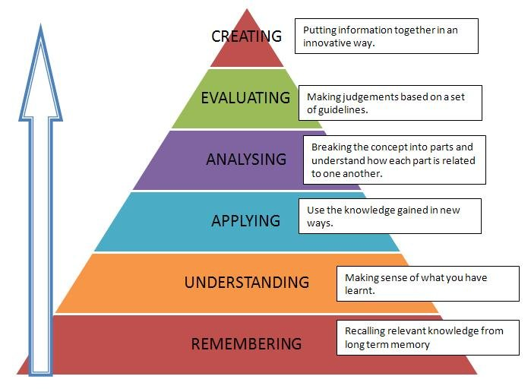
Reflection:

Oftentimes we make mental notes of this part of the lesson, but rarely/take time to formally reflect or record how the lesson went. We know that self-reflecting, like self-evaluation, make our teaching practices stronger. It is important to recognize when we are reflecting vs. when we are being too critical of our teaching practice or ourselves. Amazing support staff and administration, like I have at my school, are often in and out of classrooms informally and are quick to provide immediate feedback. This is an important piece of the reflection process.

