K. Merrick Canadian Families 12
Family Lifecycle Cartoon Assignment

Outcome 1.5 Identify possible stages of an individual’s family life cycle.
Now that you have correctly identified your family’s stage in the lifecycle, I want you to think about typical family issues that occur at this stage.
Task: 1) You will find one cartoon/comic strip for each of the stages of the Family Life Cycle. Each cartoon/comic strip should demonstrate some of the daily issues faced by a family during each stage. It may be humorous, serious, dramatic, or playful. There are many challenges facing our families today, so you will have plenty of material to choose from.
2) Please explain your comic and label the family lifecycle stage for each one. You may use the attached actual family comic strips as your inspiration.
Examples:
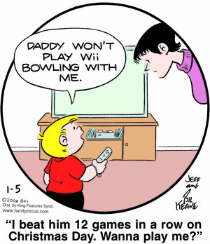
Family lifecycle stage: Stage #4 Parenting
Issue: Technology is an integral part of our daily family lives. Something that the younger generations take for granted. Parents often see technology as a way to baby sit their children while they get family chores done. It is important at a young age to be a proactive part of your children’s technological experiences. Integrate technology into family time.

_____________________________________________________________________________________
Family lifecycle stage: Stage #5 Launching
Issue: Families today suffer from a generation gap. Things HAVE changed since our parents were teens. The issues that teens face today are different than they had to deal with. Yes, you do think about girls/guys and you what is on your minds. You want parents and adults to get to know who you are, not just who you they think you are.

Family Life Cycle

Stages in a Family Life Cycle:
1. Single /individual | No children, no long term relationship
2. Marriage - Beginning Stage | A couple might marry, establish a home, and be in a committed relationship.
3. Childbearing Stage | The couple prepares and adjusts to being new parents.
4. Parenting | Caring for Children and coping with demands on energy and attention with less privacy at home.
5. Launching Stage | When the oldest child is between the ages of 13 and 20. Children gradually leave home to support themselves. Parents help their children adapt to life on their own.
6. Middle Age Marriages - Empty Nest  Stage | After the last child has left home, the couple renews their relationship and adjusts to the change in their parenting. Parents more likely to divorce at this time. Parents who stayed together just for the children feel free to move on.
7. Grandparenting - Retirement Stage | The couple adjusts to the aging process. They may develop new interests or renew old ones.

